

**Revision History**

| **Date** | **Version** | **Author** | **Change Description** |
| --- | --- | --- | --- |
| 11/03/2021 | 0.1 | Ton Nu Khanh Quynh | Initial creation |
| 11/12/2021 | 0.2 | Ton Nu Khanh Quynh | Second draft |
| 11/24/2021 | 0.3 | Ton Nu Khanh Quynh | Third draft |
| 01/12/2021 | 0.4 | Ton Nu Khanh Quynh | The Final |

**Approval**

| **Date** | **Version** | **Approver Name** | **Position** |
| --- | --- | --- | --- |
|  | 0.1 |  | Application Owner |
|  | 0.1 |  | ITPM |

**Table of Contents**

1 Objective and Scope 4

2 Business Requirement 4

2.1. Application Overview 4

2.2. Domain Model 5

2.2.1. Diagram 5

2.2.2. Domain Objects Description 6

2.3. Workflow 7

2.4. Use Cases and Actors 9

2.4.1. Diagram 9

2.4.2. Description of Actors 12

2.4.3. Description of Use Cases 13

2.5. Security Matrix 14

2.6. Change Requirement 16

3 Appendix 17

3.1. Glossary 17

3.2. Open Issues 17

**List of Figures**

Figure 1: Domain Model 5

Figure 2: Workflow 6

Figure 3: State Transition Diagram 7

Figure 4: Admin Use Case Diagram 8

Figure 5: User Use case Diagram 9

Figure 6: Normal User Use Case Diagram 10

Figure 7: Silver User Use Case Diagram 11

Figure 8: Gold User Use Case Diagram 12

# Objective and Scope

This document describes the business requirements for Social Networking Dating Project. It contains the overall description of the application, the scope of data migration, and any changes need to be performed during migration the application.

This document along with the prototype demo is used for requirements confirmation, and it is to be signed off by the business. Details of business logic and graphic user interface of the application, which are not mentioned in this document, will be migrated as they are in the application.

# Business Requirement

# Application Overview

# Domain Model

# Diagram

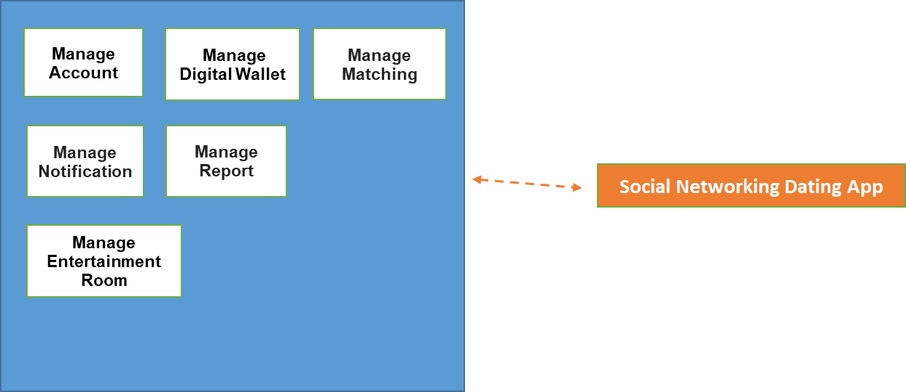

*Figure 1: Domain Model*

# Domain Objects Description

| # | Object Name | Object Description |
| --- | --- | --- |
| 1 | Manage Account | Describe the account user use to access the system |
| 2 | Manage Digital Wallet | Describe the administrator in the system |
| 3 | Manage Notification | Describe the notification user received during their using time |
| 4 | Manage Matching | Describe the tasks related to matching |
| 5 | Manage Entertainment room | Describe the rooms created to serve user’ entertainment demand |
| 6 | Manage User Information | Describe the user information (including general and details) |
| 7 | Manage Post | Describe the user posts |
| 8 | Manage Report | Describe the reports of users |

# Workflow

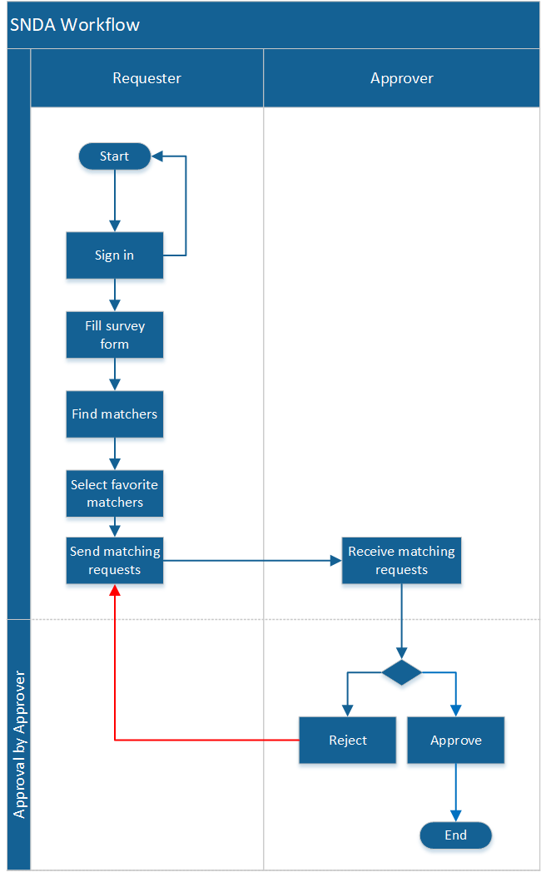

*Figure 2: Workflow*

State Transition Diagram

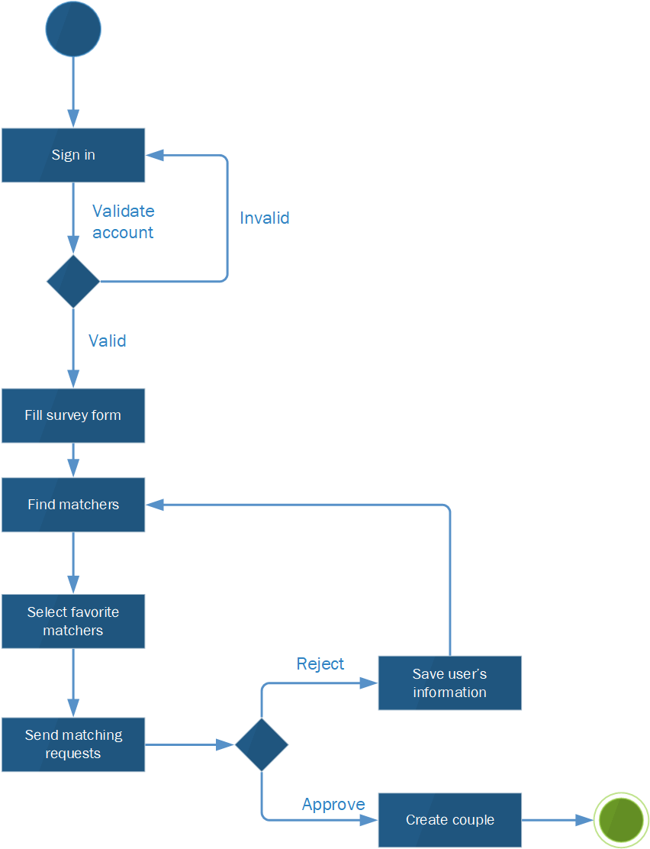

*Figure 3: State Transition Diagram*

# Use Cases and Actors

# Diagram

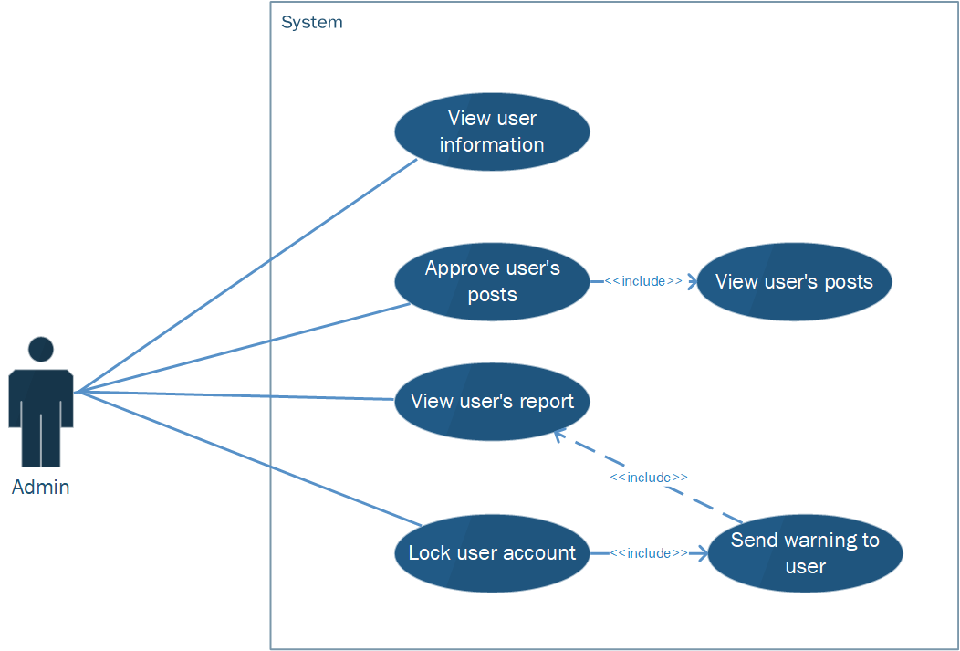

*Figure 4: Admin Use Case Diagram*

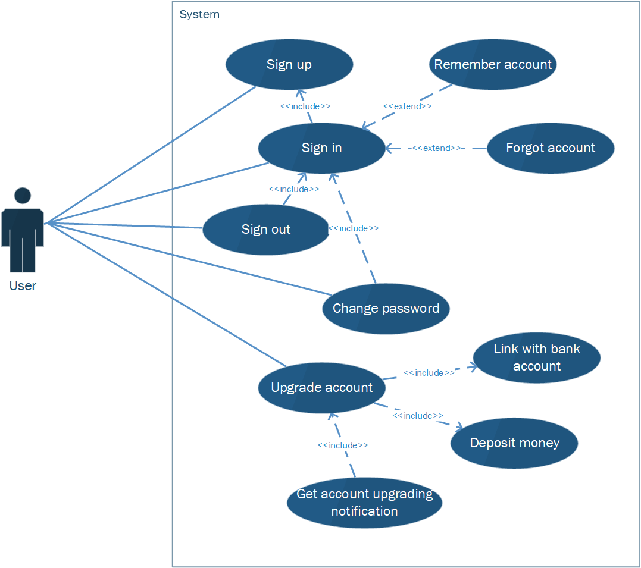

*Figure 5: User Use case Diagram*

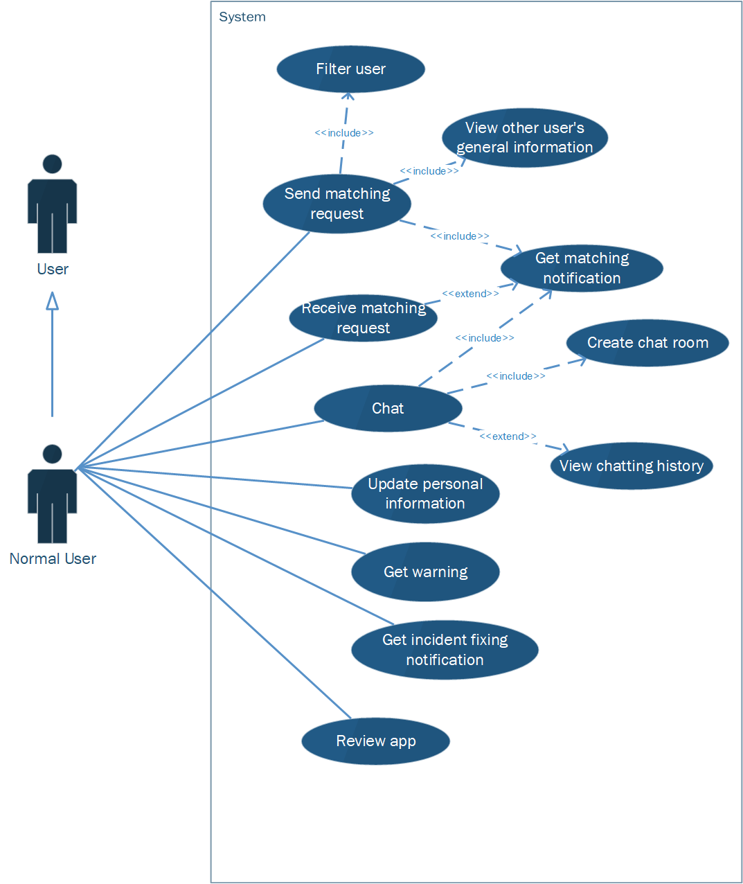

*Figure 6: Normal User Use Case Diagram*

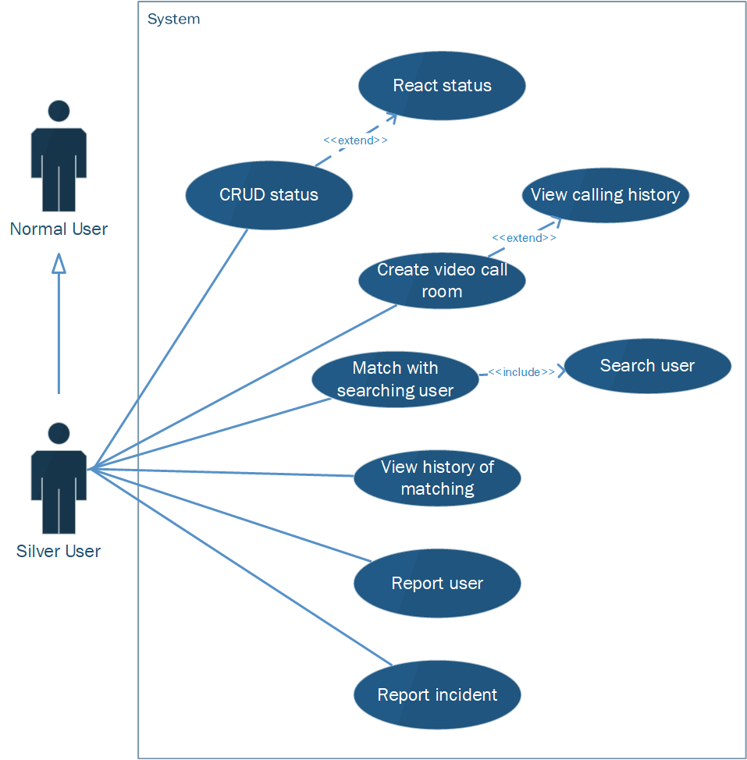

*Figure 7: Silver User Use Case Diagram*



*Figure 8: Gold User Use Case Diagram*

# Description of Actors

| # | Actor Name | Definition |
| --- | --- | --- |
| 1 | Admin | An actor has ability to manage user information, approve user postings, receive and handle reports from users. |
| 2 | Normal user | A person has ability to request matching and be matched with another corresponding user. In addition, this person can create room for chatting and upgrade account to using more functions in the app. |
| 3 | Silver user | A person has ability to conduct all functions of normal user with more benefits and some additional functions such as: filtering by user’s hobbies, habits; creating video call room, reporting other users, reporting incidents, viewing matching history. |
| 4 | Gold user | A person has ability to carry out all functionalities of silver user with more benefits and some additional features such as: add user into their favorites list, block other users, increasing the frequency of appearance on the finding list. |

# Description of Use Cases

* Use Cases of Administrator:

| # | Use Case Name | Definition |
| --- | --- | --- |
| 1 | View user information | This use case allows administrators to view user information, including full name, gender, year of birth, city, hobbies. |
| 2 | View user’s posts | This use case allows administrator to view posts posted by users |
| 3 | Approve user’s posts | This use case allows administrator to approve posts posted by users |
| 4 | View user’s reports | This use case allows administrator to view report sent by users |
| 5 | Lock user account | This use case allows the administrator to lock user account. |
| 6 | Send warning to user | This use case allows the administrator to send a warning to user. |

* Use Cases of User:

| # | Use Case Name | Definition |
| --- | --- | --- |
| 1 | Sign up | This use case allows users to sign in the system. |
| 2 | Sign in | This use case allows users to create their account. |
| 3 | Sign out | This use case allows users to sign out from the system. |
| 4 | Remember account | This use case allows users to sign in in the next time without retyping account information |
| 5 | Forgot account | This use case allows users to set a new password via verification code. |
| 6 | Change password | This use case allows users to change their password. |
| 7 | Upgrade account | This use case allows users to upgrade their level of account |
| 8 | Link with bank account | This use case allows users to link the application with their bank account. |
| 9 | Deposit money | This use case allows users to deposit money into its own digital wallet |
| 10 | Get account upgrading notification | This use case allows users to receive notification of their account upgrading status. |

* Use Cases of Normal User:

| # | Use Case Name | Definition |
| --- | --- | --- |
| 1 | Filter user | This use case allows users to find a list of corresponding users. |
| 2 | Send matching request | This use case allows users to send matching requests to other users they want. |
| 3 | View user’s general information | This use case allows users to view other user’ general information. |
| 4 | Receive matching request | This use case allows users to receive matching requests from other users. |
| 5 | Get matching notification | This use case allows users to get notification about matching status. |
| 6 | Create chat room | This use case allows users to chat with other users they matched |
| 7 | View chatting history | This use case allows user to review messages between this user with other users |
| 8 | Chat | This use case allows user to send messages to other users matched |
| 9 | Update personal information | This use case allows users to their personal information. |
| 10 | Get warning | This use case allows users to get warning about their non-standardized behavior. |
| 11 | Get incident fixing notification | This use case allows users to get notification about incident fixing status |
| 12 | Review app | This use case allows users to review app. |

* Use Cases of Silver User:

| # | Use Case Name | Definition |
| --- | --- | --- |
| 1 | Match with searching user | This use case allows user to send matching request with user searched |
| 2 | Search user | This use case allows user to search other users based on user nickname. |
| 3 | Create video call room | This use case allows users to have video calls with other users they matched |
| 4 | View calling history | This use case allows users to review calling history. |
| 5 | View history of matching | This use case allows users to review information of previous matching. |
| 6 | Report user | This use case allows users to report other users when other users have non-standardized/ harassing behaviors. |
| 7 | Report incident | This use case allows users to report incidents occurred during their using time. |
| 8 | CRUD status | This use case allows users to create, remove and edit status on the user wall. |
| 9 | React status | This use case allows users to react post posted by themselves and other users. |

* Use Cases of Gold user:

| # | Use Case Name | Definition |
| --- | --- | --- |
| 1 | Add to the Favorites list | This use case allows user to add users to the Favorites list |
| 2 | View Favorites list | This use case allows user to view list of favorite users. |
| 4 | Block user | This use case allows user to block other user accounts. |
| 5 | Boost account | This use case allows user to make user profile become one of the top ones in user’s area for 30 minutes. |

# Security Matrix

| **Group**  **Function / Data** | **Normal User** | **Silver User** | **Gold User** | **Administrator** | **System Timer** |
| --- | --- | --- | --- | --- | --- |
| **Manage “Account”** |  |  |  |  |  |
| Sign in | X | X | X | X |  |
| Sign up | X | X | X |  |  |
| Sign out | X | X | X | X |  |
| Remember account | X | X | X | X |  |
| Forgot password | X | X | X |  |  |
| Change password | X | X | X | X |  |
| Upgrade account | X | X |  |  |  |
| Block account |  |  | X |  |  |
| Lock account |  |  |  | X |  |
| Unblock account |  |  |  | X |  |
| Boost account |  |  | X |  |  |
| **Manage “Digital Wallet”** |  |  |  |  |  |
| Link bank account | X | X | X |  |  |
| Deposit money into digital wallet | X | X | X |  |  |
| **Manage “Notification”** |  |  |  |  |  |
| Get notification | X | X | X |  |  |
| Send warning |  |  |  | X |  |
| **Manage “Matching”** |  |  |  |  |  |
| Send matching request | X | X | X |  |  |
| Receive matching request | X | X | X |  |  |
| View matching history |  | X | X |  |  |
| Match with searching user |  | X | X |  |  |
| **Manage “Entertainment room”** |  |  |  |  |  |
| Create chat room | X(*) | X(*) | X(*) |  |  |
| View chatting history | X(*) | X(*) | X(*) |  |  |
| Chat | X(*) | X(*) | X(*) |  |  |
| Create video call room |  | X(*) | X(*) |  |  |
| View calling history |  | X(*) | X(*) |  |  |
| **Manage “User Information”** |  |  |  |  |  |
| View general user information | X | X | X |  |  |
| View user information |  |  |  | X |  |
| Edit personal information | X | X | X |  |  |
| **Manage “Post”** |  |  |  |  |  |
| Create, Remove |  | X(*) | X(*) | X |  |
| Edit |  | X(*) | X(*) |  |  |
| View | X | X | X | X |  |
| React |  | X | X |  |  |
| **Manage “Report”** |  |  |  |  |  |
| Report user |  | X | X |  |  |
| Report incident |  | X | X | X |  |
| View user report |  |  |  | X |  |
| Filter users | X | X | X |  |  |
| Search user |  | X | X |  |  |
| Add to the Favorites list |  |  | X |  |  |
| View Favorites list |  |  | X |  |  |
| Approve user post |  |  |  | X | x |
| Review app | X | X | X |  |  |

X: The user has full permission to do the action.

X(*): The user has permission on his items.

# Change Requirement

| # | Item Name | Change Description |
| --- | --- | --- |
| 1 |  |  |
| 2 |  |  |
| 3 |  |  |
| 4 |  |  |
| 5 |  |  |
| 6 |  |  |
| 7 |  |  |

# Appendix

# Glossary

| Term | Description |
| --- | --- |
| BRD | Business Requirements Document |
| DB | Database |
|  |  |

# Open Issues